**Title: Toy Racer Robotic Car with L298N Motor Driver**

**INTRODUCTION**

A Bluetooth controlled RC car is a car controlled by a remote control. The car is driven by an app imbedded in an Android mobile device. The subjected driven car is made up of the following components:

**COMPONENTS**

We have used the following components to make All Direction Robotic Car:

1. 12V DC Motor
2. Arduino Uno
3. 1298N Motor Driver
4. 12V, 3.5A battery (Rechargeable)
5. Mecanum Wheels
6. HC – 05 Bluetooth Module

**12V DC MOTOR**

It is a Special type of DC Motor that runs on a 12-volt DC Supply. it is a general-purpose DC motor. Most of the household electronics machine consists of a 12-volt dc motor. The current rating of this motor depends on the load of the motor. The speed of DC motors is specified in Revolution Per Meter (RPM).

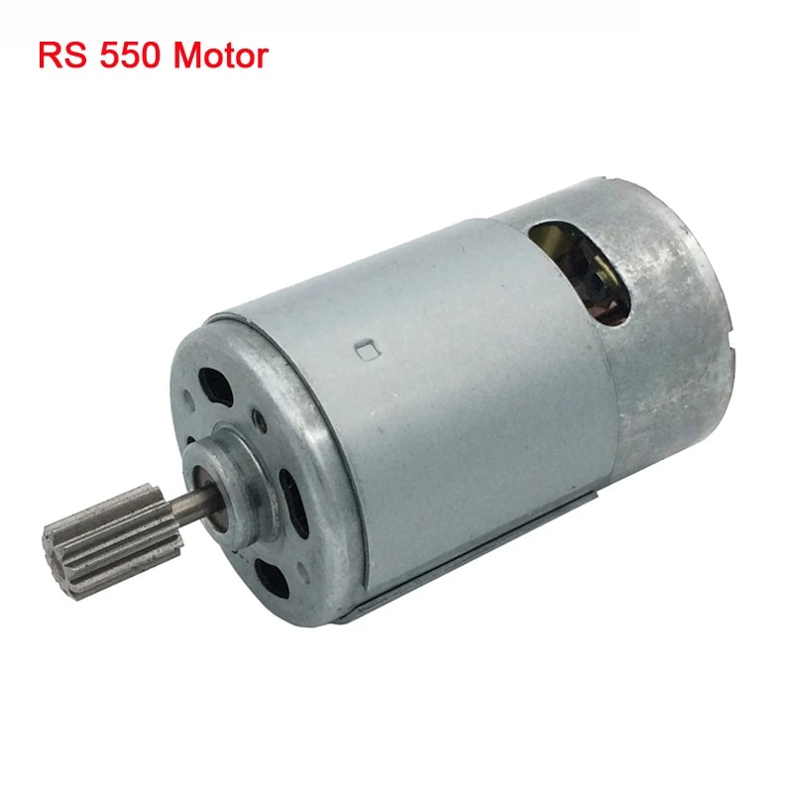

Figure : 12V DC motor

**ELECTRIC MOTOR GEAR TRANSMISSION 12V**

This Gear Reduction box is used to produce more torque against the weight of toy car. The middle gear is made of metal which is sturdier and more durable. It will make quite low noise and more wear resistant. There are 4 types for different voltage and speed that you can choose as need.

Specifications:

* Type (Optional): 12V 12000RPM
* Total length: Approx. 16.5cm / 6.5inch
* Hole Diameter: 1cm / 0.39in
* Quantity: 1
* Weight: approx. 270-289g

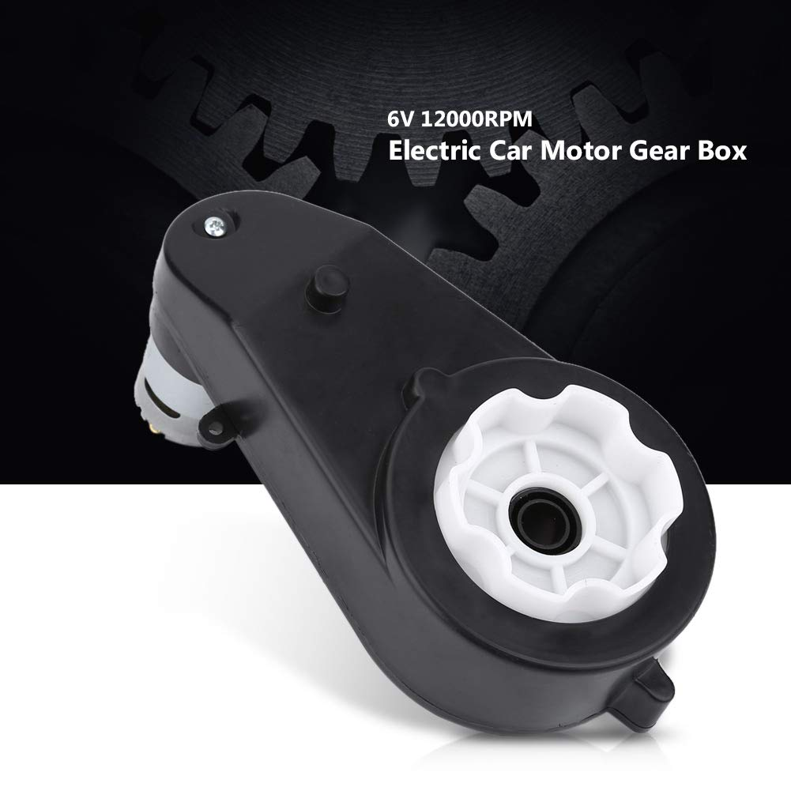

Figure : Electric Motor Gear Transmission 12V

**HC – 05 BLUETOOTH MODULE**

The HC-05 Bluetooth module is a module designed for wireless serial communication. It is a slave module meaning that it can receive serial data when serial data is sent out from a master Bluetooth device (device able to send serial data through the air: smart phones, PC).

Figure : HC-05 Bluetooth Module

**ARDUINO UNO**

The Arduino Uno is an open-source microcontroller board based on the Microchip ATmega328P microcontroller and developed by Arduino.cc. This board can be interfaced with other Arduino boards, Arduino shields, Raspberry Pi boards and can control relays, LEDs, servos, and motors as an output.

Arduino UNO features AVR microcontroller Atmega328, 6 analogue input pins, and 14 digital I/O pins out of which 6 are used as PWM output.

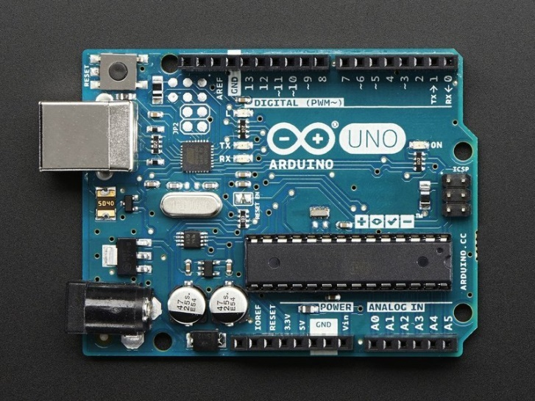

Figure : Arduino Uno

**L298N MOTOR DRIVERS**

L298N module is a high voltage, high current dual full-bridge motor driver module for controlling DC motor and stepper motor. It can control both the speed and rotation direction of two DC motors. This module consists of an L298 dual-channel H-Bridge motor driver IC. This module uses two techniques for the control speed and rotation direction of the DC motors.

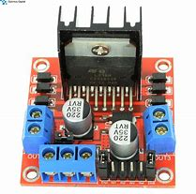

Figure : L298N Motor Driver

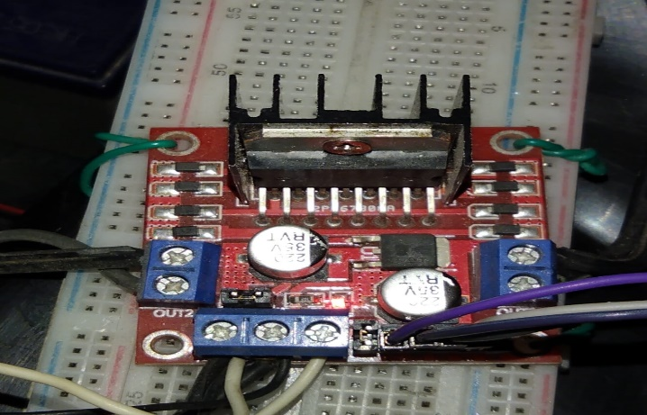

Figure : L298N Motor Driver Actual picture

**18650 CELL**

An 18650 is a lithium-ion rechargeable battery. Their proper name is “18650 cell”. The 18650 cell has voltage of 3.7v and has between 1800mAh and 3500mAh (mili-amp-hours).18650s may have a voltage range between 2.5 volts and 4.2 volts, or a charging voltage of 4.2 volts, but the nominal voltage of a standard 18650 is 3.7 volts.

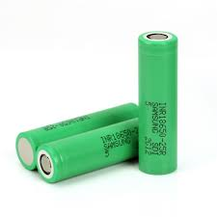

Figure : 18650 Battery

* **Types**

There are two types: protected and unprotected. Protected cells include a protection circuit that stops the cell from being overcharged. Unprotected cells can be overcharged and burst or potentially cause a fire unless there are specific electronics to protect the battery. The popular LG HG2 and Samsung 25r are both UNPROTECTED batteries, only use them in a device designed to use unprotected 18650s

* **Charge time**

The average 18650 battery charge time is about 30 minutes. Charge time can vary with amperage and voltage of the charger and the battery type.

**TOY CAR**

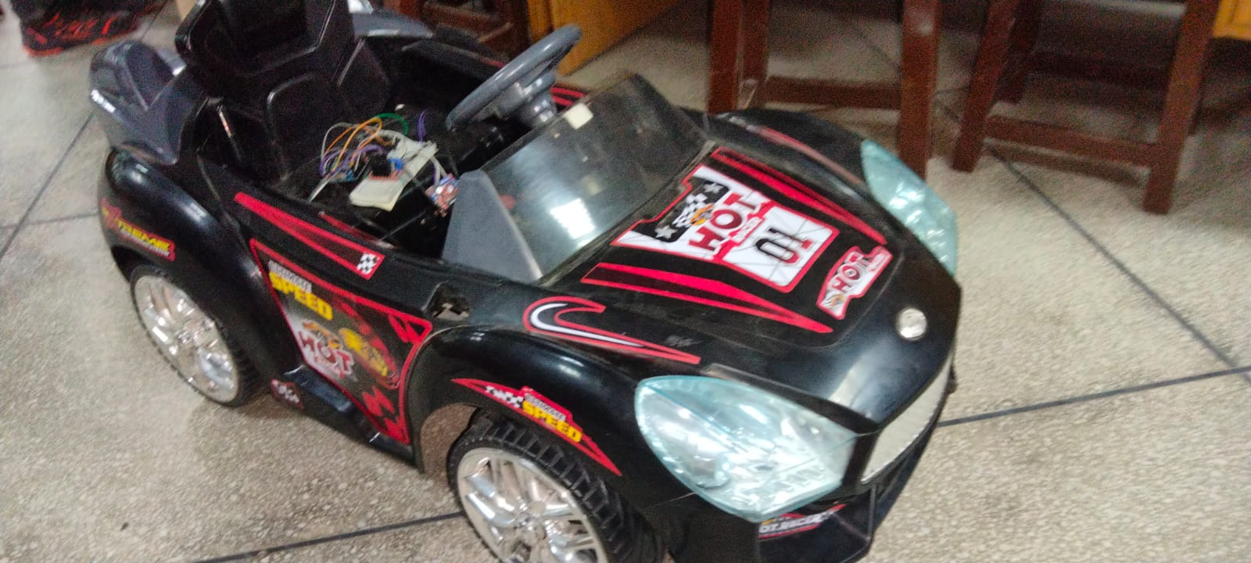

Figure : Toy Car

**SCHEMATIC DIAGRAM**

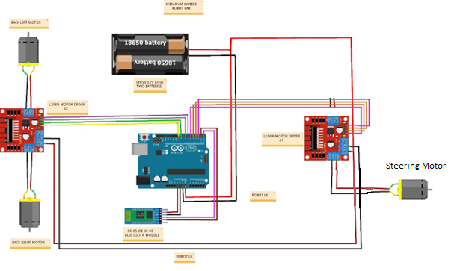

Figure : Schematic Diagram

**PIN CONFIGRATION**

|  |  |  |
| --- | --- | --- |
| **Arduino UNO Pin** | **Bluetooth HC-05 Pin** | **L298N Motor Driver** |
| +5V | Vcc |  |
| GND | GND | GND |
| Rx | Tx |  |
| Tx | Rx |  |
| D5, D6 |  | Back Right Motor (L298N #1 in-3&4) |
| D10, D11 |  | Back Left Motor (L298N #1 in-1&2) |
| D12, D13 |  | Steering Wheel Motor (L298N #1 in-1&2) |
| Vin |  | +5V |

**WORKING OF PROJECT**

The brain of this robot platform is an Arduino Uno board which controls each wheel individually. Each wheel is attached on a BO motor and knowing the fact that BO motors can be precisely controlled. We can wirelessly control the robot using the HC-05 Bluetooth modules

For powering the whole robot, we will use 12V power supply, and in our project, we are using 18650 cells which provides around 12V. For the Bluetooth communication we are using the HC-05 Bluetooth module. We also included a dedicated 5V voltage regulator which can provide around 3A of current. This is optional, like for driving Arduino board etc.

**CODE USED**

|  |
| --- |
| #define in1 5 //L298n Motor Driver pins.  #define in2 6  #define in3 10  #define in4 11  #define srv1 12  #define srv2 13  int command; //Int to store app command state.  int Speed = 204; // 0 - 255.  int Speedsec;  int buttonState = 0;  int lastButtonState = 0;  int Turnradius = 0; //Set the radius of a turn, 0 - 255 Note:the robot will malfunction if this is higher than int Speed.  int brakeTime = 45;  int brkonoff = 1; //1 for the electronic braking system, 0 for normal.  void setup() {  pinMode(in1, OUTPUT);  pinMode(in2, OUTPUT);  pinMode(in3, OUTPUT);  pinMode(in4, OUTPUT);  pinMode(srv1, OUTPUT); //Set the srv1 pin.  pinMode(srv2, OUTPUT); //Set the srv1 pin.  Serial.begin(9600); //Set the baud rate to your Bluetooth module.  }  void loop() {  if (Serial.available() > 0) {  command = Serial.read();  Stop(); //Initialize with motors stoped.  switch (command) {  case 'F':  forward();  break;  case 'B':  back();  break;  case 'L':  left();  break;  case 'R':  right();  break;  case 'G':  forwardleft();  break;  case 'I':  forwardright();  break;  case 'H':  backleft();  break;  case 'J':  backright();  break;  case '0':  Speed = 100;  break;  case '1':  Speed = 140;  break;  case '2':  Speed = 153;  break;  case '3':  Speed = 165;  break;  case '4':  Speed = 178;  break;  case '5':  Speed = 191;  break;  case '6':  Speed = 204;  break;  case '7':  Speed = 216;  break;  case '8':  Speed = 229;  break;  case '9':  Speed = 242;  break;  case 'q':  Speed = 255;  break;  }  Speedsec = Turnradius;  if (brkonoff == 1) {  brakeOn();  } else {  brakeOff();  }  }  }  void forward() {  analogWrite(in1, Speed);  analogWrite(in3, Speed);  }  void back() {  analogWrite(in2, Speed);  analogWrite(in4, Speed);  }  void left() {  analogWrite(srv1, Speed);  }  void right() {  analogWrite(srv2, Speed);  }  void forwardleft() {  analogWrite(in1, Speed);  analogWrite(in3, Speed);  analogWrite(srv1, Speed);  }  void forwardright() {  analogWrite(in1, Speed);  analogWrite(in3, Speed);  analogWrite(srv2, Speed);  }  void backright() {  analogWrite(in2, Speed);  analogWrite(in4, Speed);  analogWrite(srv1, Speed);  }  void backleft() {  analogWrite(in2, Speed);  analogWrite(in4, Speed);  analogWrite(srv2, Speed);  }  void Stop() {  analogWrite(in1, 0);  analogWrite(in2, 0);  analogWrite(in3, 0);  analogWrite(in4, 0);  analogWrite(srv1, 0);  analogWrite(srv2, 0);  }  void brakeOn() {  //Here's the future use: an electronic braking system!  // read the pushbutton input pin:  buttonState = command;  // compare the buttonState to its previous state  if (buttonState != lastButtonState) {  // if the state has changed, increment the counter  if (buttonState == 'S') {  if (lastButtonState != buttonState) {  digitalWrite(in1, HIGH);  digitalWrite(in2, HIGH);  digitalWrite(in3, HIGH);  digitalWrite(in4, HIGH);  delay(brakeTime);  Stop();  }  }  // save the current state as the last state,  //for next time through the loop  lastButtonState = buttonState;  }  }  void brakeOff() {  } |

**PROJECT PICTURES:**



Figure : Upper view of Toy Car

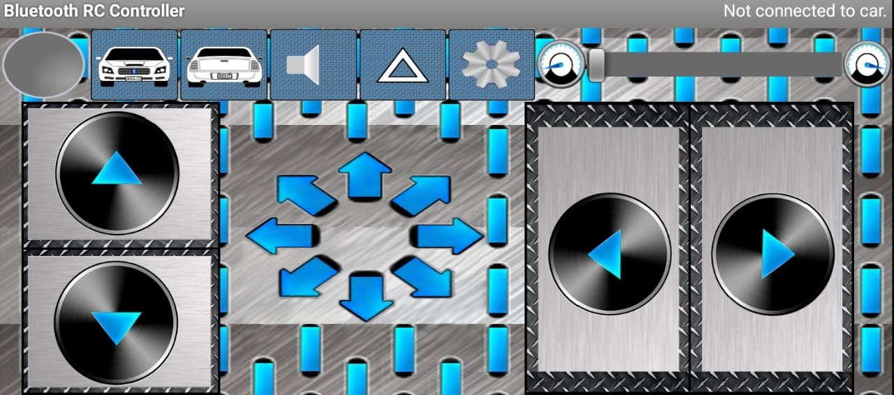

Figure : Full view of Mobile application

* **Buy Project Parts Here**

<https://hallroad.org/>

* **Wheel Buy link**

[Arduino UPS Generators Pakistan (arduinopak.com)](https://www.arduinopak.com/Search.aspx?Search_Term=mecanum%20wheel)

* **App link**

<https://play.google.com/store/apps/details?id=braulio.calle.bluetoothRCcontroller>